Experiment 1
Experiment to be conducted using WEKA tool:
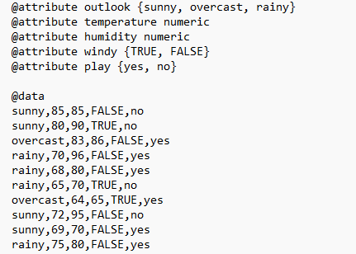
- Preprocess(Data Cleaning, Data Integration, Data Transformation, Data Reduction) and Classify (Posteriori and Priori) panels. Analyze Input and Output Attributes.
- Data Cleaning : Dataset has no null values
- Data Integration: Data is pre-collected and stored into a single weather. nominal dataset in arff file
- Data Transformation: Data doesn’t need any label encoding and all values lies in a range of below 100
- Data Reduction: this is a dataset with least number of attributes of 4 so no need of reduction
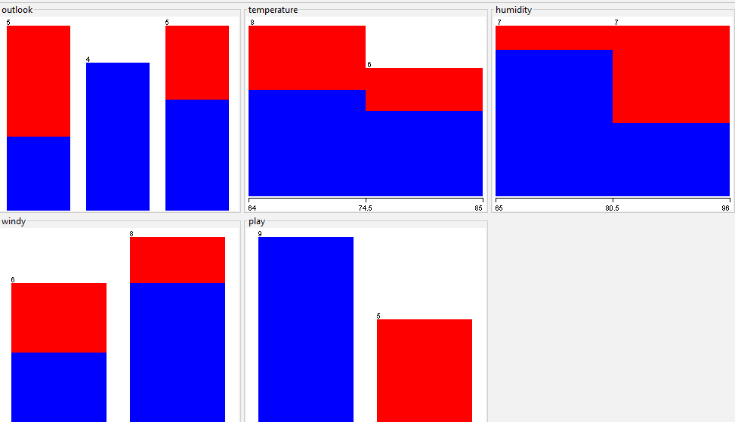
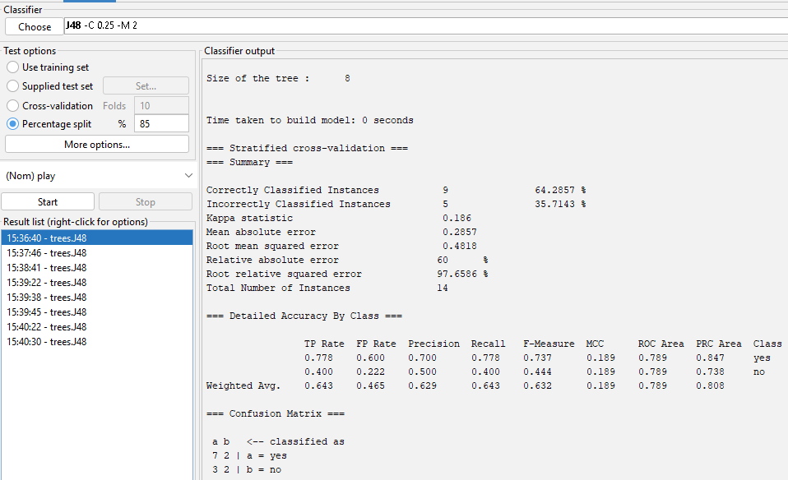

- Calculate the information of the whole data set on the basis of whether play is held or not.
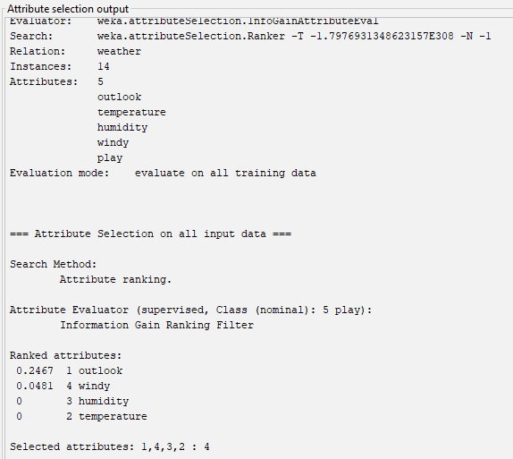

Inference:
The Information Gain-based attribute selection method was applied to the Weather dataset using Play as the class attribute. The results show that Outlook has the highest Information Gain of 0.2467, indicating that it provides the greatest amount of information for predicting whether the game will be played. Windy is the second-ranked attribute with an Information Gain of 0.0481. Humidity and Temperature obtained an Information Gain of 0, indicating that they did not provide additional information according to this particular attribute evaluation configuration. Therefore, the attributes are ranked as Outlook, Windy, Humidity, and Temperature.

- Draw the histogram to show how the values of the play class occurs for each value of the outlook attribute

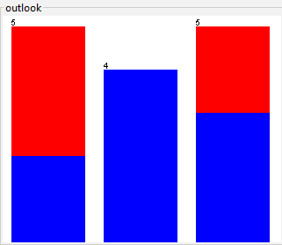
Inference:
The visualization shows the distribution of the class attribute Play with respect to Outlook. When the outlook is Overcast, all 4 instances correspond to Play = Yes, making this category completely pure. For Sunny conditions, there are 2 instances of Yes and 3 instances of No, while for Rainy conditions, there are 3 instances of Yes and 2 instances of No. Thus, Outlook provides a clear separation of the Play classes, particularly for the Overcast category. This is consistent with the Information Gain result, where Outlook had the highest Information Gain (0.2467).

- Derive minimum and maximum values, mean, and standard deviation
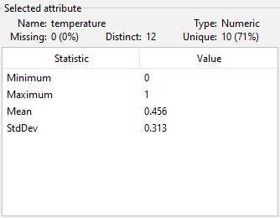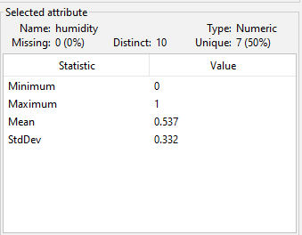
Inference: Temperature has a mean of 0.456 and humidity has a mean of 0.537. Their standard deviations are 0.313 and 0.332, respectively, indicating moderate variation in the data.

- Perform operations such as filter, delete, invert, Pattern, Undo, Edit, search, Select, Conversions etc
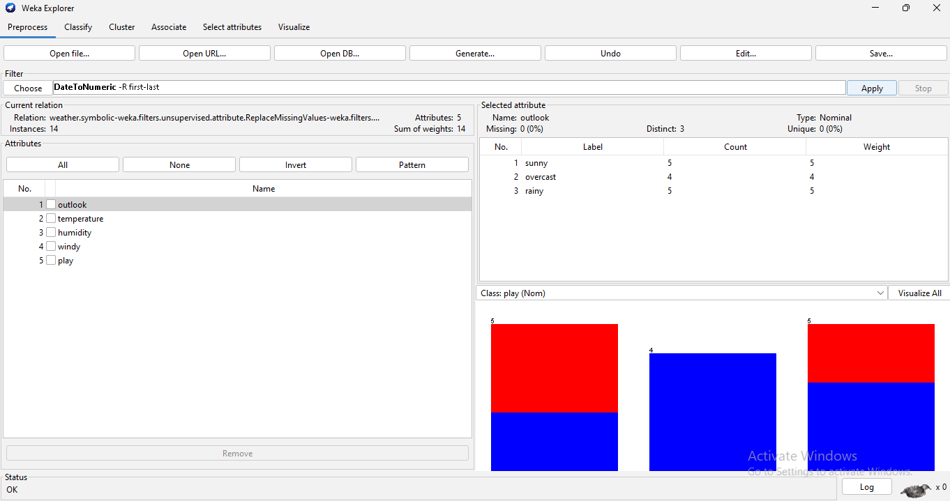
Inference:
The WEKA Preprocess panel was used to perform dataset manipulation and filtering operations. The interface provides options such as All, None, Invert, Pattern, Undo, Edit and filter selection for preprocessing the data.

- Examine the Output , classification error and Kappa statistics

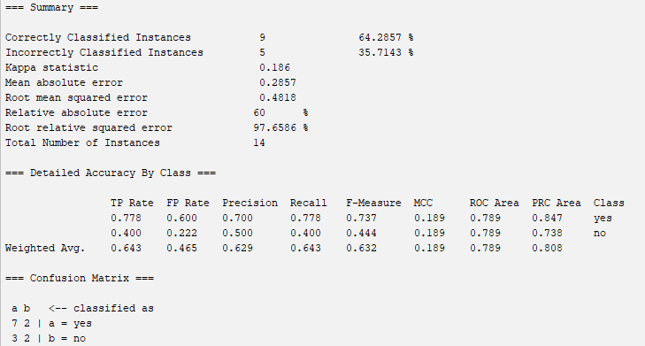
Accuracy: 64.29%
Classification Error: 35.71%
Kappa: 0.186 → Slight agreement
Best predicted class: Yes
Classification: Non Discrete

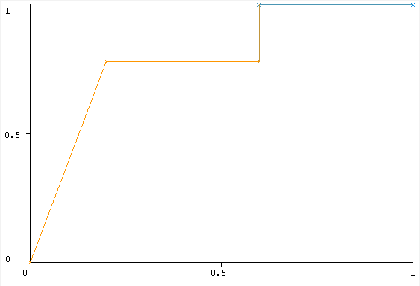
- Visualize threshold curve
Inference: The ROC curve shows a ROC Area (AUC) of 0.789, indicating that the model has a reasonable ability to distinguish between the Yes and No classes.

- Apply Logistic Regression model to classify
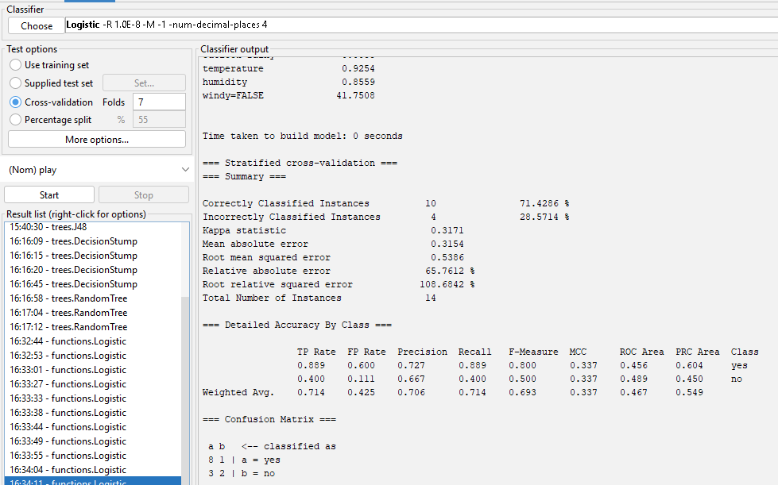
Inference: The Logistic Regression model correctly classified 71.43% of the 14 instances, while 28.57% were incorrectly classified. The weighted F-measure is 0.693 and the ROC Area is 0.467. The confusion matrix shows 10 correct and 4 incorrect predictions, indicating moderate classification performance.
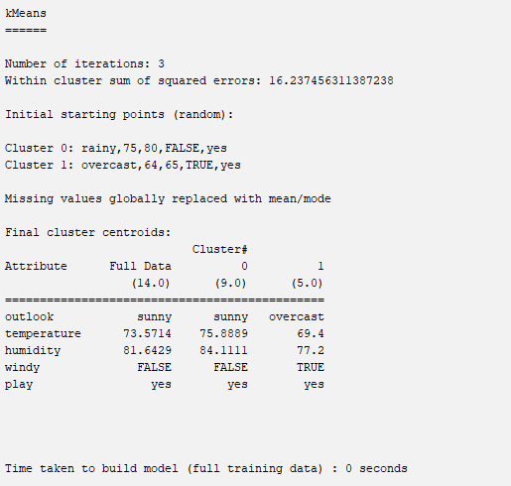
- Measure the log likelihood of the clusters of training data. (Consider large data set.)

Inference: The K-Means algorithm grouped the 14 instances into 2 clusters after 3 iterations. Cluster 0 contains 9 instances, while Cluster 1 contains 5 instances. The final centroids show that Cluster 0 is mainly associated with Sunny, lower temperature, higher humidity, and FALSE windy, while Cluster 1 is associated with Overcast, lower humidity, and TRUE windy. The within-cluster sum of squared errors is 16.2375.

- Derive Information gain
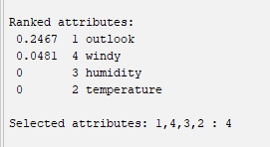
Inference: The attributes are ranked based on Information Gain. Outlook has the highest value (0.2467), followed by Windy (0.0481). Humidity and Temperature have an Information Gain of 0. All four attributes were selected for the model.

- Build Decision Tree on Humidity attribute. Also demonstrate decision tree after analysis of
- Sunny and Overcast dataset
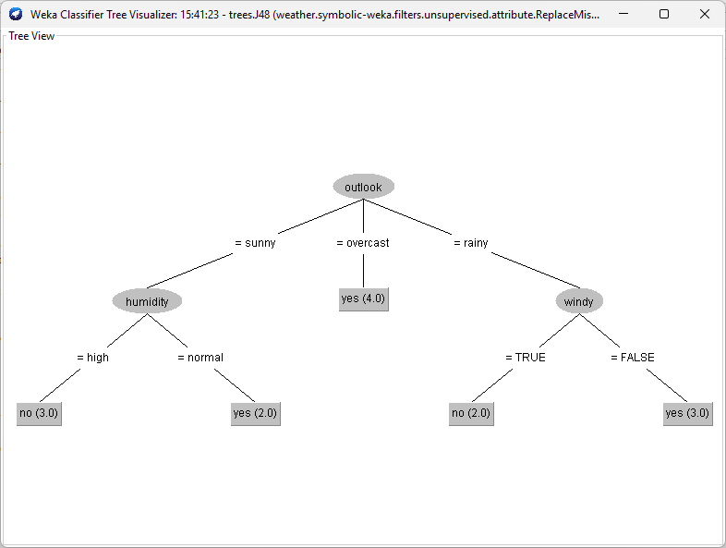
Inference: The J48 decision tree uses Outlook as the root attribute. For Overcast, all 4 instances are classified as Yes. For Sunny, the prediction depends on Humidity: High → No and Normal → Yes. For Rainy, the prediction depends on Windy: TRUE → No and FALSE → Yes.

- Sunny, Overcast and Rainy Data set

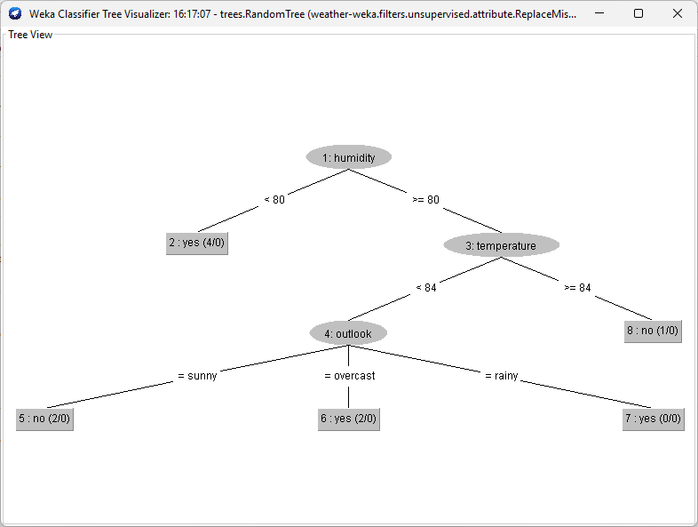
Inference: The RandomTree model first splits the data based on Humidity. Instances with humidity < 80 are classified as Yes. For humidity ≥ 80, the model further considers Temperature and then Outlook. The tree classifies Temperature ≥ 84 as No, while lower temperatures are further classified using Outlook

- Compute Gini Index representing with respect to Temperature, Humidity, and Windy attributes.

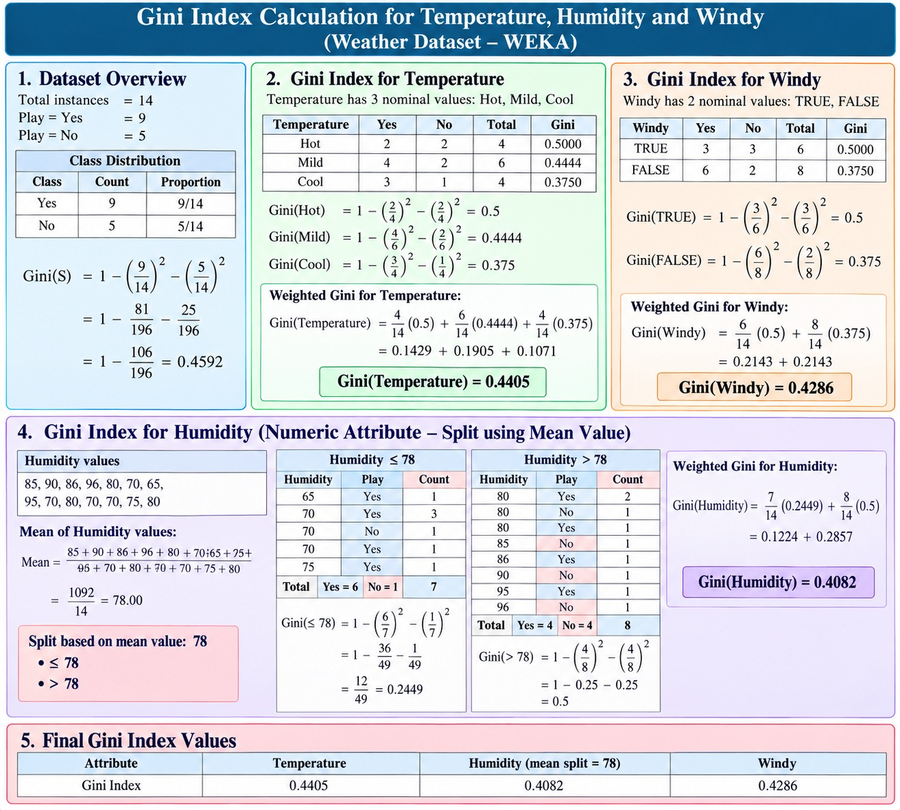
Inference: The Gini Index was calculated for Temperature, Humidity, and Windy. The obtained values are 0.4405, 0.4082, and 0.4286, respectively, indicating the impurity associated with each attribute split.
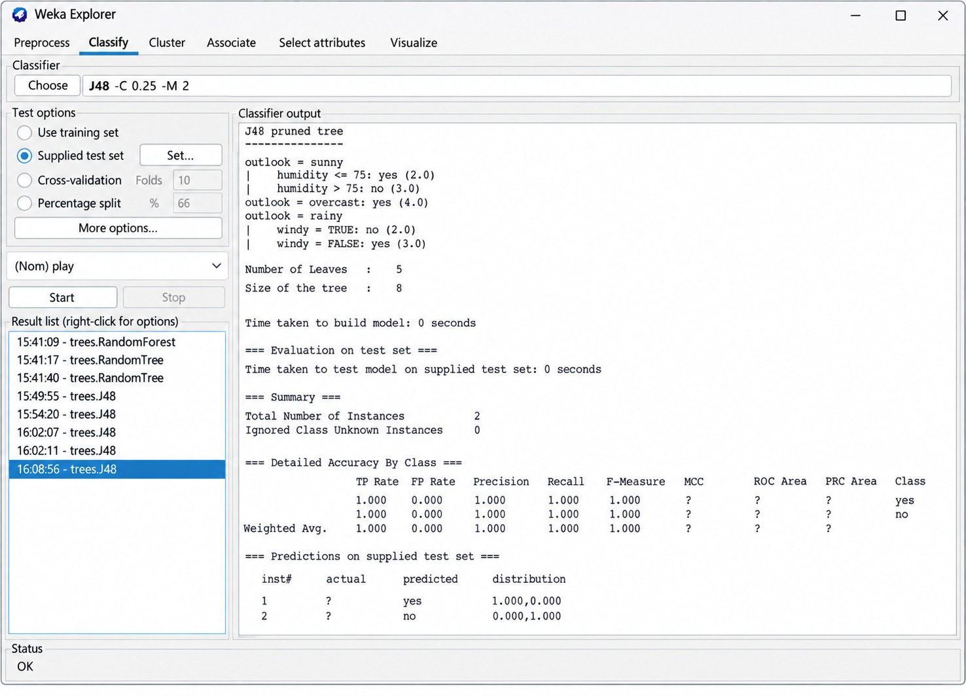
- Obtain the Prediction of Play ‘Yes’ as well as ‘No’ for an unknown instance

Inference: The J48 classifier was tested on 2 unknown instances using a supplied test set. The model predicted Yes for the first instance and No for the second instance, with a probability of 1.0 for each predicted class.
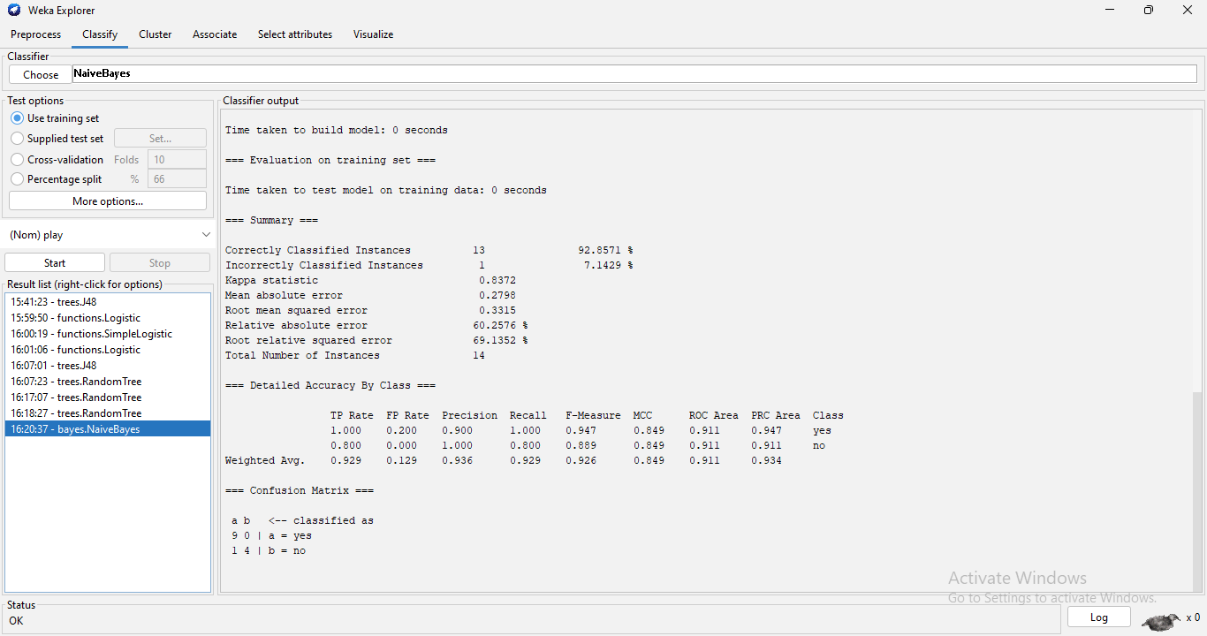
- Apply Naïve Bayes Classifier to the Weather play data set and derive the probability for play no given outlook rainy

Inference:
The Naive Bayes classifier was applied to the Weather dataset and achieved 92.86% classification accuracy. It can be used to estimate the probability of play = no for a new instance having outlook = rainy using Bayes' theorem.

- Apply classification on given data. Remove label and then apply clustering. Perform class to cluster evaluation. Apply classification on un labelled dataset by removing play attribute. Prepare the analysis report. Interpret the results.
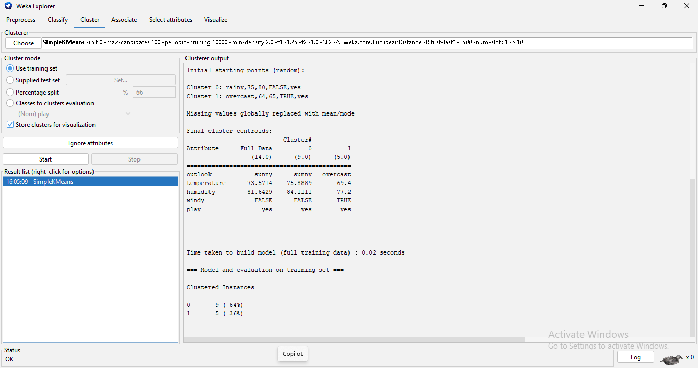
Inference:
After removing/ignoring the class label, SimpleKMeans grouped the 14 instances into two clusters, containing 9 and 5 instances respectively. The clusters were formed based on similarity between the remaining Weather attributes.

